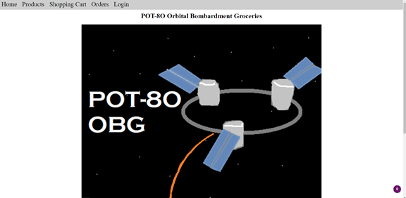Main Page where users initiate their exploration of our website.

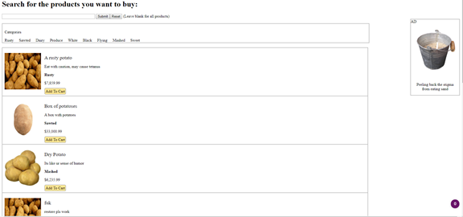

Product page to find and purchase products, do note there is space for advertising on the right side of the page. Categories are present to fine tune the searches

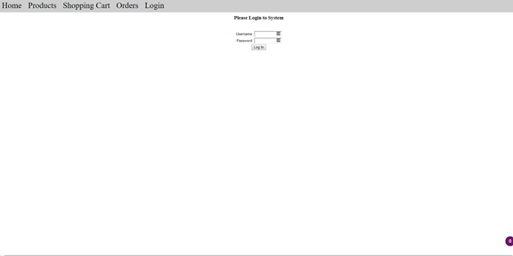

Users can login

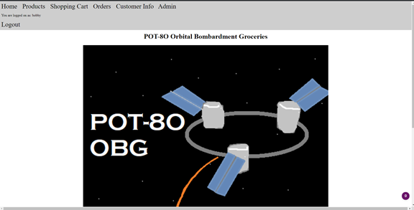

Welcome page changes for people that log in

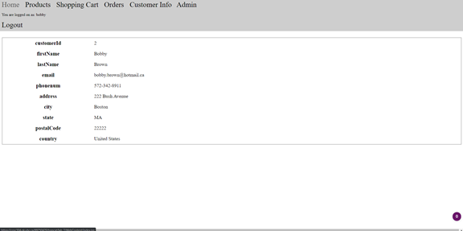

Customer info is present

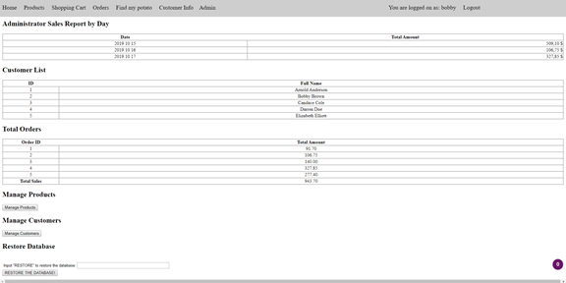

Admin pages give the option to see some customer infos, add new products, add customers and restore the database.

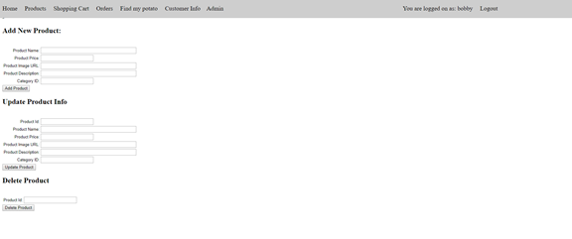

Many information can be added to existing products. Products can also be added or deleted.

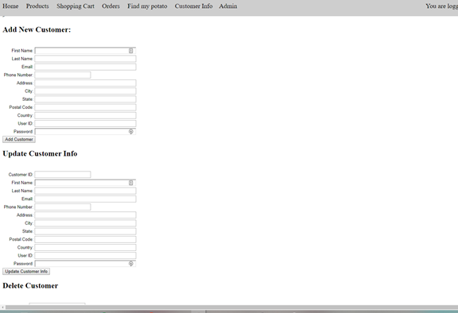

Customers can be added or deleted.

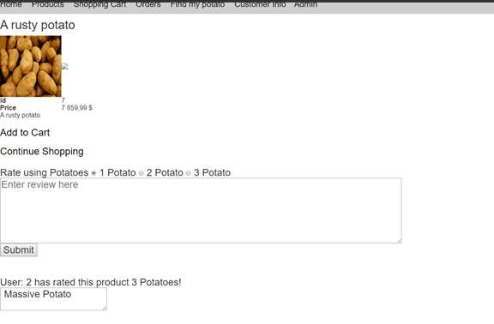

Each product has its own data page with user reviews

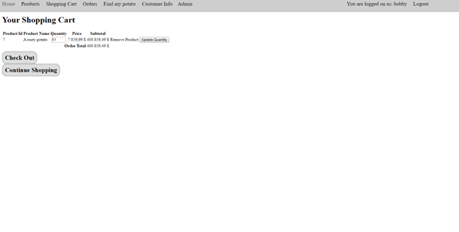

Once products are selected, customers can change the quantity or delete items from their shopping carts.

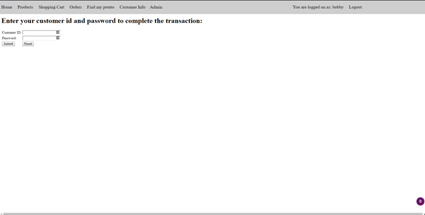

Checking out requires confirmation through a second login

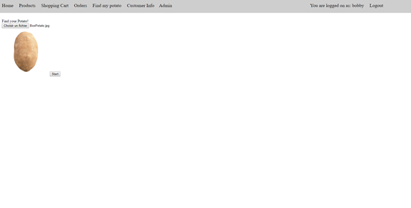

Users can upload images to let our machine learning program find their potatoes for them, this program has been trained using google’s teachable machine.

Warehouse:

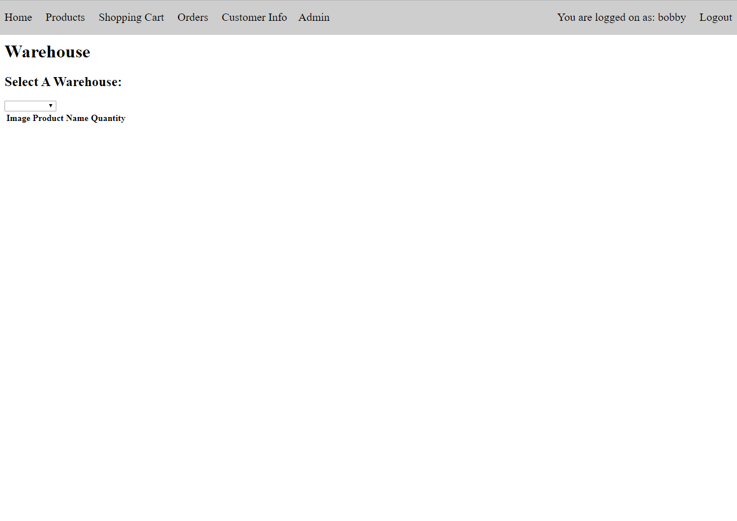

User can select warehouse from a dropdown menu

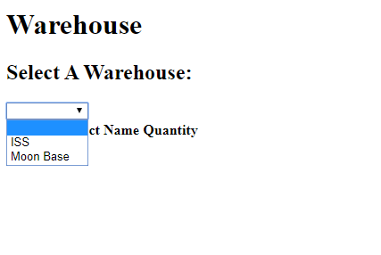

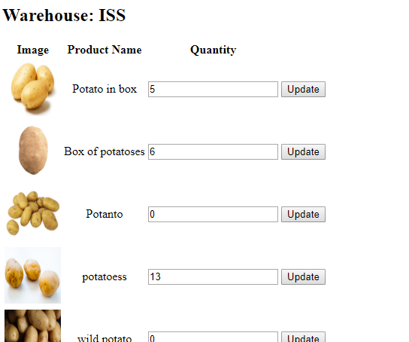

User can change the quantity of any item in the box then update the database with the update button

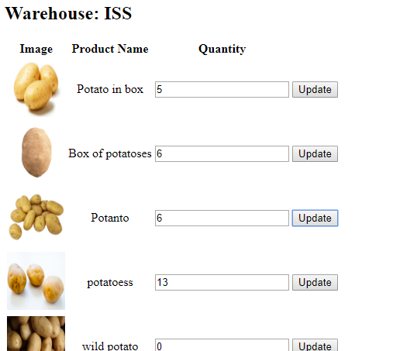

Users can create an account and the form has data validation